**CHAPTER 4**

**DESIGN**

**4.1 Entity Relationship Diagram**

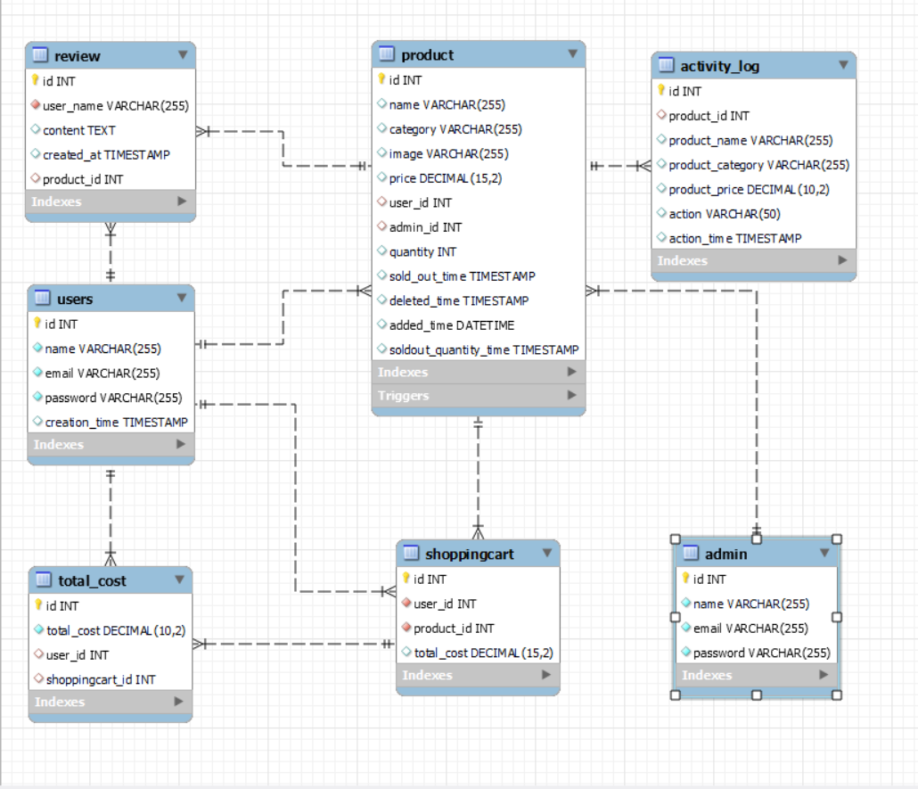

**Figure 4.1: Entity Relationship Diagram for Jewelry Palace**